**RRJETAT E KOMPJUTERAVE 1**

**LAB 10**

**Tema:** Konfigurimi i VLAN (Virtual Local Area Network) dhe rrugezimi Inter-VLAN per nje Rrjet

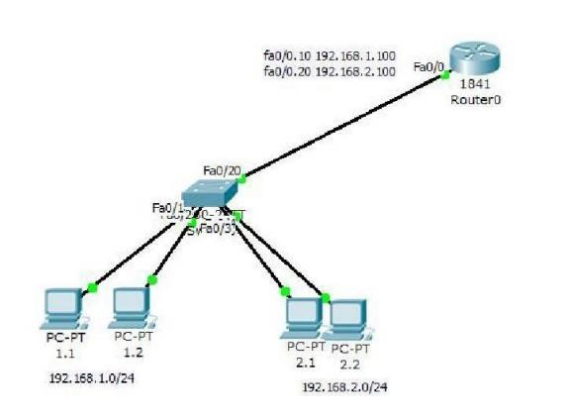

1. Create VLAN and shift the ports
2. Configure on switch fa0/ 20 as trunk port
3. Create sub intrefaces on router port fa0/ 0
4. Verify connectivity between VLANs (ping 192.168.1.1 ---192.168.2.1)

Skema e krijuar ne Packtet Tracer

1. Create VLAN and shift the ports.
2. Configure on switch fa0/ 20 as trunk port

Tek Switch , konfigurojmë rrjetet VLAN si në figurë. Kemi 2 rrjeta VLAN që i kam quajtur VLAN10 dhe VLAN20 të cilët përcaktojnë rrjetat e PC si në figuré.

1. Create sub interfaces on router port fa0/ 0

Këtu kemi përcaktuar sub interfaces te Router si f0/0.10 dhe f0/0.20.

1. A screenshot of a computer screen

   Description automatically generatedVerify connectivity between VLANs (ping 192.168.1.1 ---192.168.2.1)

Këtu kam bere ping prej PC 1.1 ne adresat 192.168.2.2 dhe 192.168.1.3.

Kam marre IP e mëposhtme per PC dhe router

